TLS/SSL cert creation request

Version No. | Version Date | Changes | Owner/Author | Date of Review/Expiry
V0.1 | 18-07-2025

This SOP describes how to create self-signed wallet in Oracle DB using the utility ORAPKI and importing SSL certificates into the wallet. Then, export the certificate as a plain file and share it with application team.

Prerequisites:
- port 2484 should be open for connections.
- Application team to provide the required SSL Certificates to DBA Team.

To start with, create a DB wallet location.
Recommended location would be $ORACLE_HOME/admin/SID_NAME/wallet.
In the current scenario,

- This is the location of SSL Certificate wallet for tst1mes in oramke1s DB cluster

/u01/app/oracle/product/19.3.0.0/dbee_1/admin/tst1mes1/wallet.

Copy the Certificate files to Wallet location:

- Create a listener with name LISTENER_SSL using 2484 port from rdbms home.

- Modify the listener.ora file and add the following entries.

Listener.ora File location - /u01/app/oracle/product/19.3.0.0/dbee_1/network/admin/listener.ora

SSL_CLIENT_AUTHENTICATION = FALSE

WALLET_LOCATION =
(SOURCE =
(METHOD = FILE)
(METHOD_DATA =
(DIRECTORY = /u01/app/oracle/product/19.3.0.0/dbee_1/admin/tst1mes1/wallet)
(DIRECTORY = /u01/app/oracle/product/19.3.0.0/dbee_1/admin/tst2mes1/wallet)
)
)

LISTENER_SSL =
(DESCRIPTION_LIST =
(DESCRIPTION =
(ADDRESS = (PROTOCOL = TCPS)(HOST = usmkelsorarac01.compute.ge-healthcare.net)(PORT = 2484))
)
)

SID_LIST_LISTENER_SSL =
(SID_LIST =
(SID_DESC =
(GLOBAL_DBNAME = tst1mes)
(ORACLE_HOME = /u01/app/oracle/product/19.3.0.0/dbee_1)
(SID_NAME = tst1mes1)
)
(SID_DESC =
(GLOBAL_DBNAME = tst2mes)
(ORACLE_HOME = /u01/app/oracle/product/19.3.0.0/dbee_1)
(SID_NAME = tst2mes1)
)
)

ENABLE_GLOBAL_DYNAMIC_ENDPOINT_LISTENER_SSL=ON
VALID_NODE_CHECKING_REGISTRATION_LISTENER_SSL=OFF

- Ensure wallet directory and Oracle home details are mentioned correctly.

- Add the following entries in sqlnet.ora file.

Location of sqlnet.ora file - /u01/app/oracle/product/19.3.0.0/dbee_1/network/admin

WALLET_LOCATION =
(SOURCE =
(METHOD = FILE)
(METHOD_DATA =
(DIRECTORY = /u01/app/oracle/product/19.3.0.0/dbee_1/admin/tst1mes1/wallet)
(DIRECTORY = /u01/app/oracle/product/19.3.0.0/dbee_1/admin/tst2mes1/wallet)
)
)

SQLNET.AUTHENTICATION_SERVICES = (TCPS,NTS,BEQ)
SSL_CLIENT_AUTHENTICATION = FALSE
SSL_CIPHER_SUITES = (SSL_RSA_WITH_AES_256_CBC_SHA, SSL_RSA_WITH_3DES_EDE_CBC_SHA)

SSL_VERSION=1.2

Now, perform the same steps on other nodes also if it’s for RAC.

- Create a tns for SSL connection using 2484 port and add it to local listener.

tst1mes_ssl =
(DESCRIPTION =
(ADDRESS = (PROTOCOL = TCPS)(HOST = usmkelsorarac01.compute.ge-healthcare.net)(PORT = 2484))
(CONNECT_DATA =
(SERVER = dedicated)
(SID = tst1mes1)
)
)

Add the service name at database level.

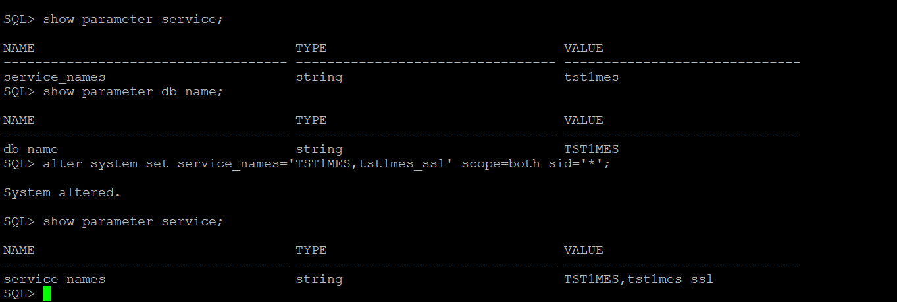

Add 2484 port to local listener parameter.

local_listener='(ADDRESS=(PROTOCOL=TCP)(HOST=10.21.138.171)(PORT=1521))','(ADDRESS=(PROTOCOL=TCPS)(HOST=usmkelsorarac01.compute.ge-healthcare.net)(PORT=2484))' SCOPE=BOTH sid='tst1mes1';

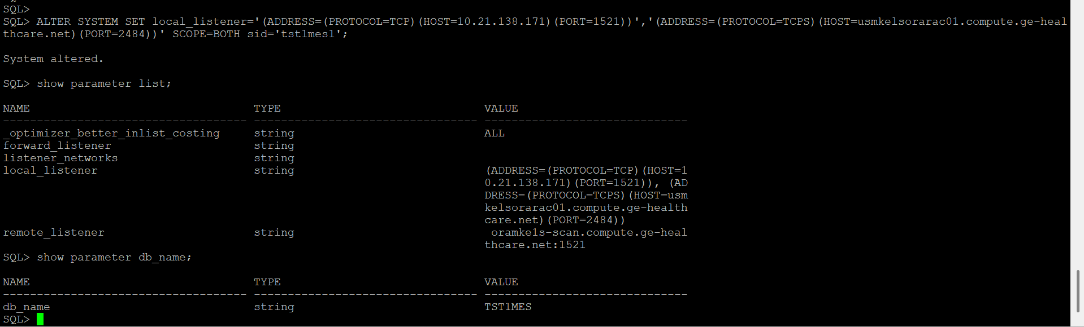

- adding the certificates to the wallet location.

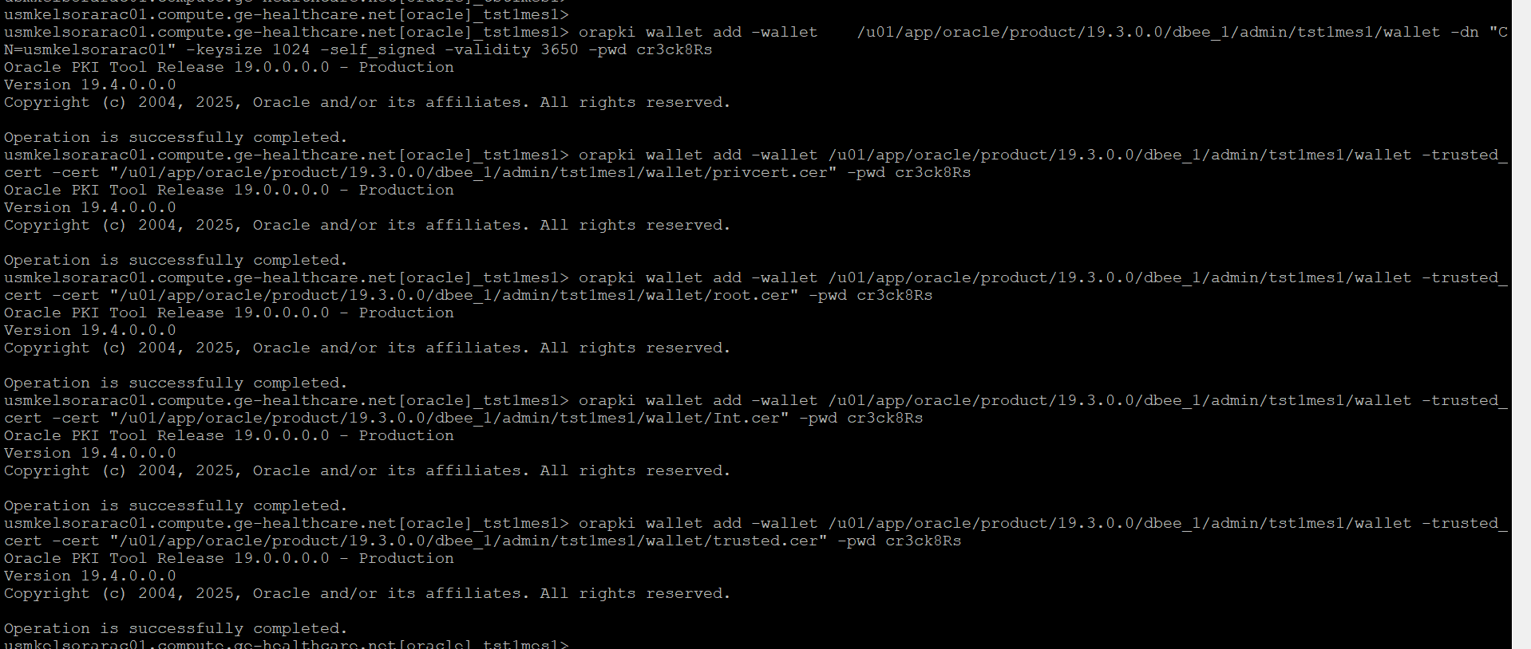

- Query the wallet once --> orapki wallet display -wallet

